

FACULTY OF TECHNOLOGY AND ENGINEERING
DEVANG PATEL INSTITUTE OF ADVANCED TECHNOLOGY AND RESEARCH

DEPARTMENT OF INFORMATION TECHNOLOGY

A.Y 2026-27 Semester-3

LAB MANUAL

CSUC201: Fundamentals of Data Structure and Algorithms



Practical 10
Practical AIM:
To implement hash tables using different collision handling strategies and develop the ability to reason about why collisions occur, how different strategies resolve them, and what trade-offs each approach involves.
Practical 10.1
Problem definition:
A small parking lot has exactly 10 numbered slots (0 to 9). When a vehicle arrives, its registration number is used to assign it a slot by taking the last digit of the number. If that slot is already taken, the vehicle moves to the next available slot in order, wrapping around if necessary. Given a sequence of vehicle registrations, assign each to a slot using this rule and display the final state of all ten slots.
Describe what your solution does when it encounters an already occupied slot. What happens when the parking lot is nearly full and many vehicles keep landing on the same slot? Can you think of a situation where your solution might loop indefinitely?
Problem faced:
I faced difficulty while handling collisions when two or more vehicle registration numbers were assigned to the same parking slot.
Solution:
I used linear probing to find the next available slot when the calculated slot was already occupied. I moved to the next slot and used modulo 10 to wrap around to the beginning. I also checked whether the parking lot was full to prevent an infinite loop.
Output:
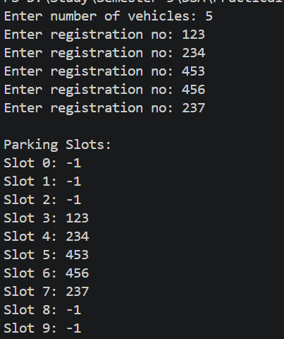
Practical 10.2
Problem definition:
A library uses a system with 10 shelves numbered 0 to 9. Each book's code is used to decide which shelf it belongs to by taking the code modulo 10. Unlike the parking lot, each shelf can hold multiple books stacked together — when two books map to the same shelf, they are simply added to that shelf's stack. Given a sequence of book codes, place each on the correct shelf and display the final contents of all shelves.
Describe how your solution handles two books that map to the same shelf. What happens to search time on a shelf as more and more books pile onto it? Can you think of what would cause all books to end up on the same shelf?
Problem faced:
I faced difficulty while handling collisions when multiple book codes mapped to the same shelf.
Solution:
I used separate chaining to store multiple book codes at the same index using a linked list. When two or more codes mapped to the same shelf, I added them to that shelf's chain and displayed the contents of every shelf.
Output:
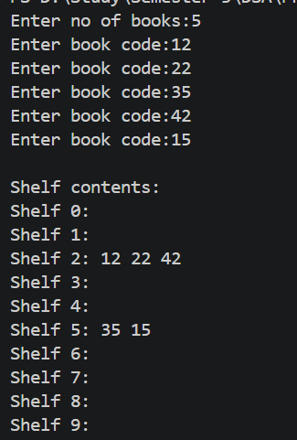
Practical 10.3
Problem definition:
A university assigns student IDs to storage slots using a two-step rule. The first rule determines the initial slot. If that slot is taken, instead of simply moving one slot forward, a second rule based on the ID itself determines how many slots to jump. This means different IDs that collide will probe different sequences of slots, spreading them more evenly. Given a sequence of student IDs, assign each to a slot using both rules and display the final state of the table.
Describe how your solution decides how many slots to jump when a collision occurs. What is the risk if the jump size happens to be a factor of the table size? How does this strategy differ from Problem 10.1 in how it spreads collisions?
Problem faced:
I faced difficulty while resolving collisions because the next position had to be calculated using a second hash function instead of simply checking the next slot.
Solution:
I used a second hash function to calculate the jump size when a collision occurred. I combined the initial hash value with the jump size to find the next position and checked whether the calculated slot was available. This helped distribute entries across the table more effectively.
Output:
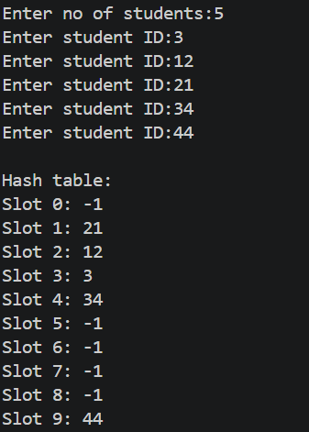

Key Questions
1. [Problem 1] If five consecutive vehicle registrations all end in the same digit, trace where each one gets placed in the parking lot. Now explain why this clustering effect is a structural weakness of this collision strategy — not just for this input, but in general.
ANS:
If five vehicle registrations end in the same digit, they initially map to the same slot. The first vehicle occupies that slot, and the remaining vehicles are placed in the next available slots. This creates a continuous group of occupied slots called primary clustering. It is a weakness because future vehicles may have to check many occupied slots, increasing insertion time.
2. [Problem 2] Suppose all book codes in Problem 2 are multiples of 10. Without tracing through the code, predict what the final shelf layout would look like and explain why. What does this tell you about the relationship between the hash function and the input data?
ANS:
All book codes will map to shelf 0 because the remainder of every multiple of 10 divided by 10 is 0. Therefore, all books will be stored in the chain at index 0, while the other shelves remain empty. This shows that the performance of a hash table depends on how well the hash function distributes the input data across the available indices.
3. [Problem 3] In Problem 3, what would happen if the second rule always produced a jump size of zero? Trace through the consequence and explain how this failure is related to the choice of the second hash function rather than the data itself.
ANS:
If the jump size is always zero, the formula keeps checking the same initial slot even when it is occupied. The program may enter an infinite loop because it never moves to another slot. This happens because the second hash function is incorrectly designed. It should produce a non-zero jump size that allows the program to reach other slots in the table.
Github link:
https://github.com/dhanvi-219/FDSA/tree/main/Practical%2010

